Instructions for abstract preparation for AT2018

J.L. First¹, P.L. Second² and J.C. Third²

¹Department of ……, University of Somewhere, City, Postcode, Country
²Department of …., University of Elsewhere, City, Postcode, Country
Keywords: first, second, third, fourth.
Associated conference topics: 2.4, 1.6, 3.5
Presenting author email: j.first@somewhere.edu

The abstract should be in double column (like this example) and ONE page long. Use A4 page set-up and make all margins (top, bottom, left, right) 20 mm wide. Start typing text about 7cm from the top of the page. Use 10 pt Times New Roman font (except for the title which should be in 12 pt bold and in sentence case). Centre the title, the authors’ names, the addresses, associated conference topics, keywords and contact email address. Please compose a title that clearly and succinctly describes the content of your work, in order to maximise its impact.
Start each paragraph, except the first, with an indent. Justify the body of the text both left and right. Do not use page numbers. Uniformity of abstract style makes the work much easier to digest! Keywords are there to draw attention to your abstract, and to help the organisers allocate the presentation to the most appropriate session.
Use clear English to write your abstract, with an emphasis on describing what is new and why it should attract the attention of the audience.
Figures can be in colour or in black and white. Ensure that Figures and Tables have a caption and that they are numbered consecutively.

Table 1. Comparison between theoretical predictions and experimental measurements.
Month | Measured density (μg/m3) | Predicted density (μg/m3)
January | 0.4 | 121
June | 2.4 | 1.528×10⁴

References should be made in the style (Book, 2004), Proc & Conf (2015) or as First et al (2017). Examples of references are shown below. Leave a blank line above the list of references, and also above the acknowledgements.
Section headings can be used, but they do take up valuable space: the same can be said of equations.

Abstract review
The abstracts will be reviewed by members of the Conference Program.
Accepted abstracts will be placed on the conference website and provided to conference attendees. Abstract titles and author lists will be listed in the conference handbook.

Submission procedure
- Use this template form to prepare your abstract.
- Below the line of Keywords, write up to three conference topics associated to the work (Ex. 2.4, 1.6, 3.5). See the Topic list in the conference website.
- During the submission process choose your preference for presentation: Oral, Poster or Any.
- In case of several submissions from the same research group, please indicate the order of preference (1, 2, 2, 3) for oral presentation. Note that in case of equal preference the same number can be used for more than one abstract.
- There will be a limited number of oral presentations. Participants should not make requests for oral presentation of several papers on similar subjects. We recommend submitting only the most general paper for oral presentation and the others for poster presentation.
- Please, submit the abstract in pdf format through the AT2018 website (www.dfmf.uned.es/AT2018). The deadline for abstract submission is 18 February 2018.
- Late posters (work in progress) can be submitted until 3 June 2018.

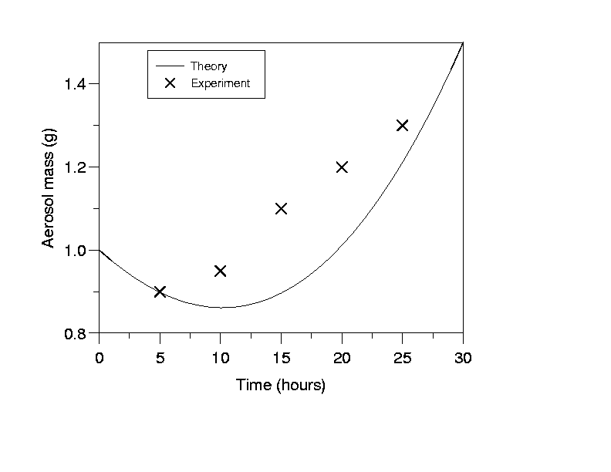
Figure 1. This is a comparison between theory and experimental data.

This work was supported by the National Council for Aerosol Research under grant AT/1212.

Book, A. (2004) Aerosol Book, Bilbao University Press.
First, J.L., Second, P.L., Third, J.C. (2017) Journal of Aerosol 45, 318-330.
Proc, E. & Conf, T. (2015) Proc. 21st Int. Conf. on Aerosols, World Scientific.

