Instructions for abstract preparation for RICTA2018

J.L. First1, P.L. Second2 and J.C. Third2

1Department of ……, University of Somewhere, City, Postcode, Country
2Department of …., Research Center, City, Postcode, Country
Keywords: first, second, third, fourth.
Associated conference topics: 2.4, 1.6, 3.5
Presenting author email: j.first@somewhere.edu

The abstract should be ONE page long. Use A4 page set-up and make all margins (top, bottom, left, right) 20 mm wide. Use 10 pt Times New Roman font (except for the title which should be in 12 pt bold). Centre the title, the authors’ names, the addresses, associated conference topics, keywords and contact email address. Please compose a title that clearly and succinctly describes the content of your work, in order to maximise its impact.
Start each paragraph, except the first, with an indent. Justify the body of the text both left and right. Do not use page numbers. Keywords and listing of associated conference topics are there to draw attention to your abstract, and to help the organisers allocate the presentation to the most appropriate session.
Figures can be in colour or in black and white. Ensure that Figures and Tables have a caption.
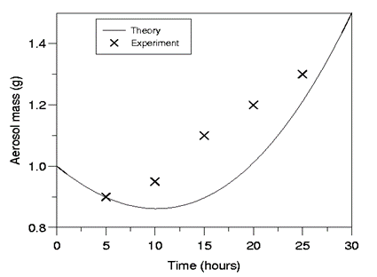
References should be made in the style (Book, 2004), Proc & Conf (2015) or as First et al (2017). Examples of references are shown below. Leave a blank line above the list of references, and also above the acknowledgements.

Table 1. Comparison between theoretical
predictions and experimental measurements.

Month | Measured density (μg/m3) | Predicted density (μg/m3)
January | 0.4 | 121
June | 2.4 | 1.528×104

Figure 1. Theory and experimental data

Abstract review
- The abstracts will be reviewed by members of the Conference Program.
- Accepted abstracts will be placed on the conference website and provided to conference attendees. Abstract titles and author lists will be listed in the conference handbook.
Submission procedure
- Use this template form to prepare your abstract.
- Below the line of keywords, write up to three conference topics associated to the work (Ex. 2.4, 1.6, 3.5). See the Topic list in the conference website.
- During the submission process choose your preference for presentation: Oral, Poster or Any.
- In case of several submissions from the same research group, please indicate the order of preference (1, 2, 2, 3) for oral presentation. Note that in case of equal preference the same number can be used for more than one abstract.
- There will a small number of oral presentations. Participants should not make requests for oral presentation of several papers. We recommend submitting only the most general paper for oral and the others for poster presentation.
- Please, submit the abstract in pdf format through the RICTA2018 website (www.dfmf.uned.es/RICTA2018). The deadline for abstract submission is April 3, 2018.
- Late posters (work in progress) can be submitted until May 26, 2018.

This work was supported by the National Council for Aerosol Research under grant RT/1212.

- Book, A. (2004) Aerosol Book, Bilbao University Press.
- First, J.L., Second, P.L., Third, J.C. (2017) Journal of Aerosol 45, 318-330.
- Proc, E. & Conf, T. (2015) Proc. 21st Int. Conf. on Aerosols, World Scientific.

